**Python Tasks**

**Q-1) Scrap any website to find out five top repeated words and perform the following:**

**a- how many times the word has been repeated.**

**b- you have to plot a graph of the output.**

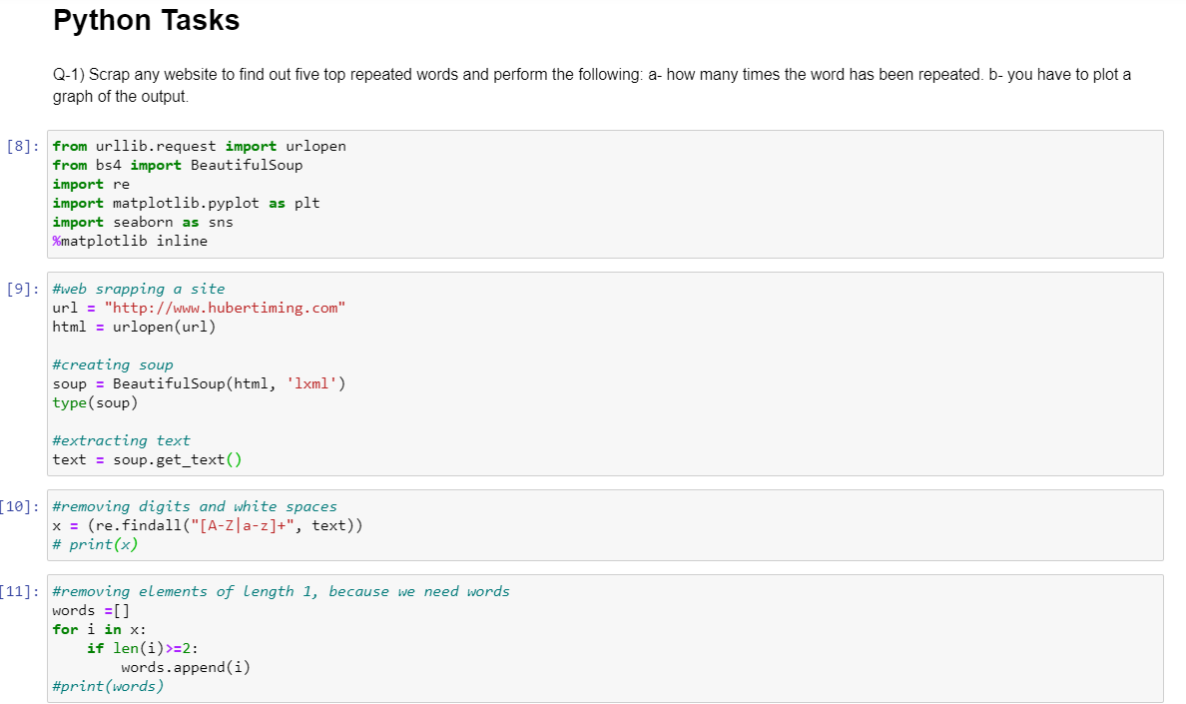

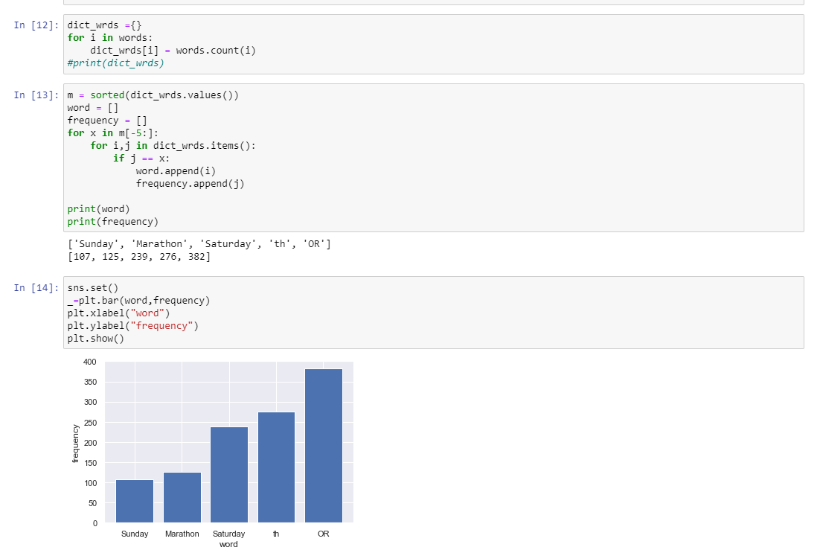

**Q-2)** **Get input from the users and it is recommended to be in voice command and you**

**need to do a sentimental analysis of the given input [ hint: use textblob library].**

